Course Outcome 2 (CO2)

1. Program to Sort strings.

**PROGRAM:**

package arraysort;

/**

*

* @author sjcet

*/

import java.util.*;

public class Arraysort {

public static void main(String[] args) {

int n;

Scanner s=new Scanner(System.in);

System.out.println("Enter the limit: ");

n=s.nextInt();

String[] ar=new String[n];

System.out.println("Enter the strings:");

for(int i=0;i<n;i++)

{

ar[i]=s.next();

}

System.out.println("\nBefore sorting the Strings are:");

for(int i=0;i<n;i++)

{

System.out.println(ar[i]);

}

String temp;

for(int i=0;i<n;i++)

{

for(int j=i+1;j<n;j++)

{

if (ar[i].compareTo(ar[j]) > 0)

{

temp = ar[i];

ar[i] = ar[j];

ar[j] = temp;

}

}

}

System.out.println("\nAfter sorting the Strings are:");

for(int i=0;i<n;i++)

{

System.out.println(ar[i]);

}

}

}

**OUTPUT:**

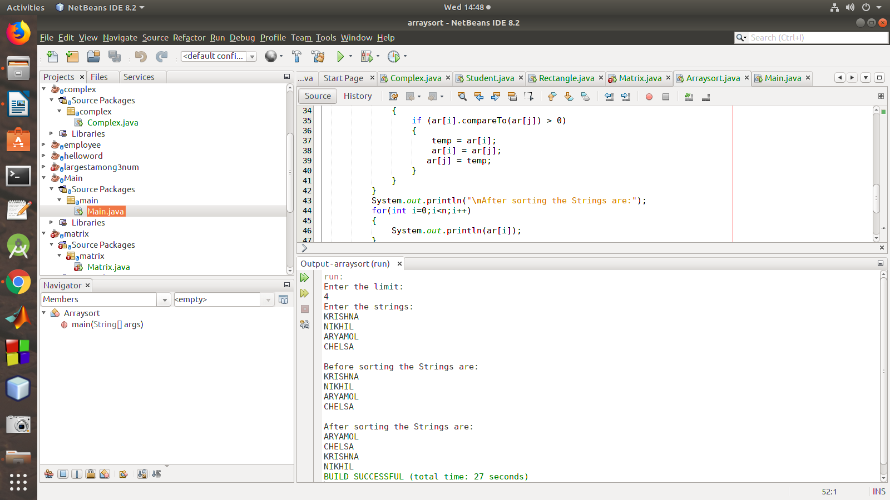

2. Perform string manipulations

**program:**

package stringmanip;

import java.util.Scanner;

public class Stringmanip {

String str1,str2;

Stringmanip(String s1,String s2){

str1=s1;

str2=s2;

}

public void strLen(){

System.out.println("\n The length of string-1 :"+str1.length());

System.out.println("\n The length of string-2 :"+str2.length());

}

public void strConcat(){

System.out.println("\n Concatenated String-1 and String-2:"+(str1.concat(str2)));

}

public void compare(){

System.out.println("\n Compare String-1 and String-2 "+(str1.equals(str2)));

}

public void LowerCase(){

System.out.println("\n lowercase of String-1 "+(str1.toLowerCase()));

}

public void UpperCase(){

System.out.println("\n uppercase of String-1 "+(str2.toUpperCase()));

}

public static void main(String[] args) {

String s1,s2;

Scanner sc =new Scanner(System.in);

System.out.println("Enter the String-1");

s1=sc.nextLine();

System.out.println("Enter the String-2");

s2=sc.nextLine();

Stringmanip s=new Stringmanip(s1,s2);

s.strLen();

s.strConcat();

s.compare();

s.LowerCase();

s.UpperCase();

}

}

**output:**

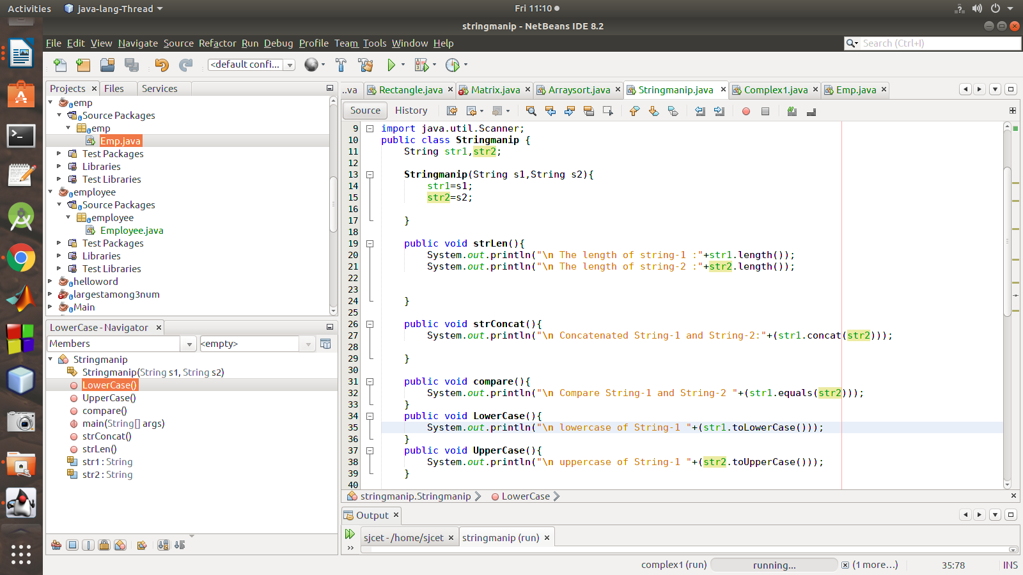

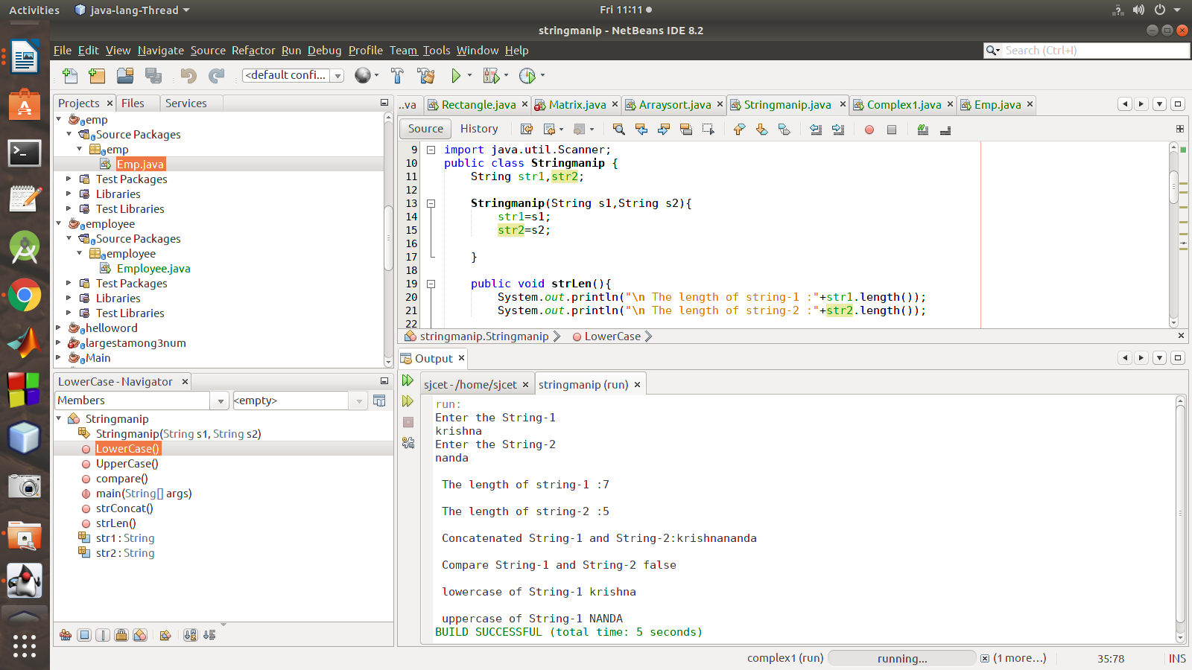

3. Program to create a class for Employee having attributes eNo, eName eSalary. Read n

employ information and Search for an employee given eNo, using the concept of Array of

Objects.

**Program:**

package emp;

import java.util.Scanner;

class Emp

{

int id;

String name;

float salary;

public static void main(String args[])

{

Scanner sc = new Scanner(System.in);

System.out.print("Enter the number of employees");

int n = sc.nextInt();

Emp emp[] = new Emp[n];

for (int i = 0; i < n; i++) {

emp[i] = new Emp();

System.out.println("Enter details of employee " + (i + 1)

);

System.out.print("Enter employee id :");

emp[i].id = sc.nextInt();

System.out.print("Enter employee name :");

emp[i].name = sc.next();

System.out.print("Enter employee salary :");

emp[i].salary = sc.nextFloat();

}

System.out.println("\n\n********* All Employee Details are:*********\n");

for (int i = 0; i < n; i++) {

System.out.print("\nEmployee Id :" + emp[0].id );

System.out.print("\nEmployee Name :" + emp[i].name );

System.out.print("\nEmployee Salary :" + emp[i].salary );

}

}

}

**output:**

